**Data Analytics SQL Mini-Project-1**

**By- Sourabh khandelwal**

Insight 1-

-- average mileage of all cars:

#comment – to know what is the average mileage of cars in the market

select avg(mileage) from car24

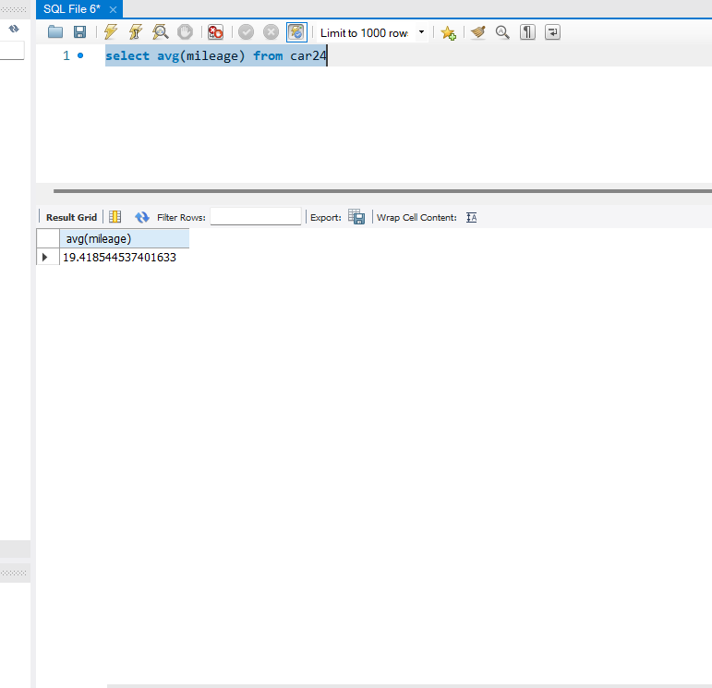

Insight-2

-max mileage of car

select max(mileage) from car24

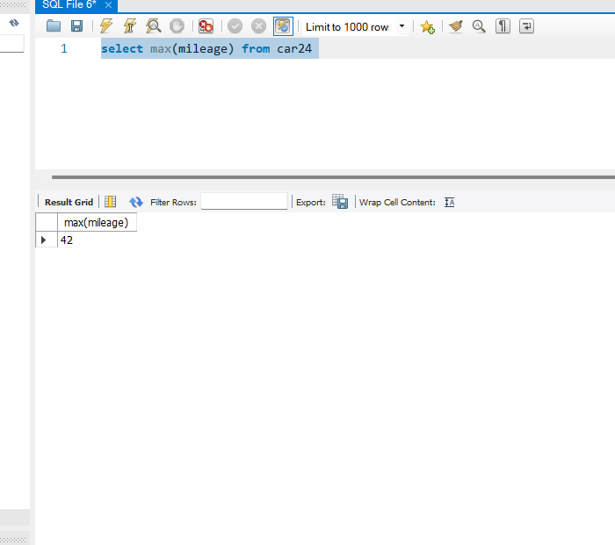

Insight 3-

-- the maximum price of a car

select max(selling_price) from car24 ;

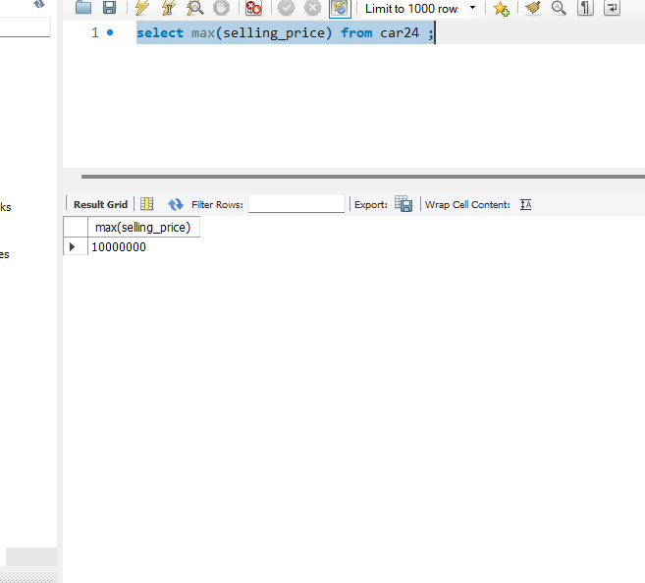

Insight 4

--the average price of all cars:

Comments- to know in which renge maxium cars been sold in past

select avg(selling_price) from car24

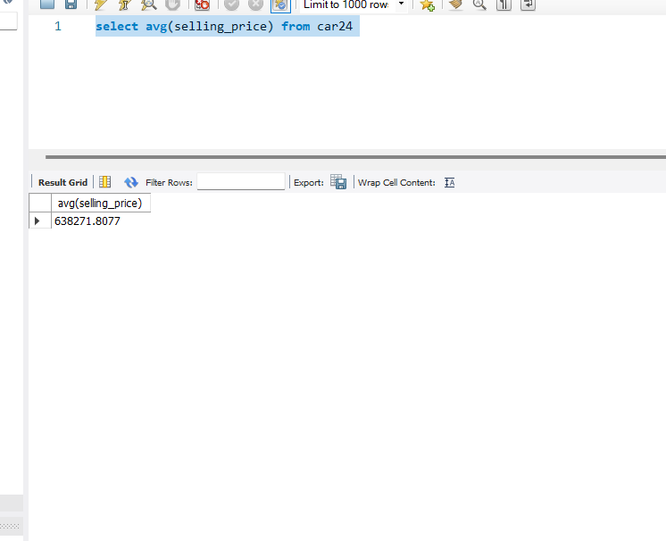

Insight 5

--the average mileage for cars manufactured after 2015

select avg(mileage) from car24

where year>2015;

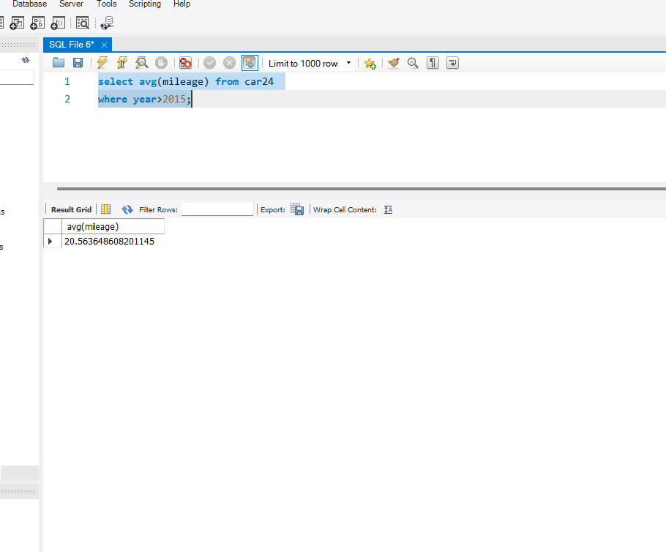

Insight 6

-Top 5 cars which have max selling_price and max_power

select name,selling_price ,max_power from car24

order by selling_price desc, max_power desc

limit 5;

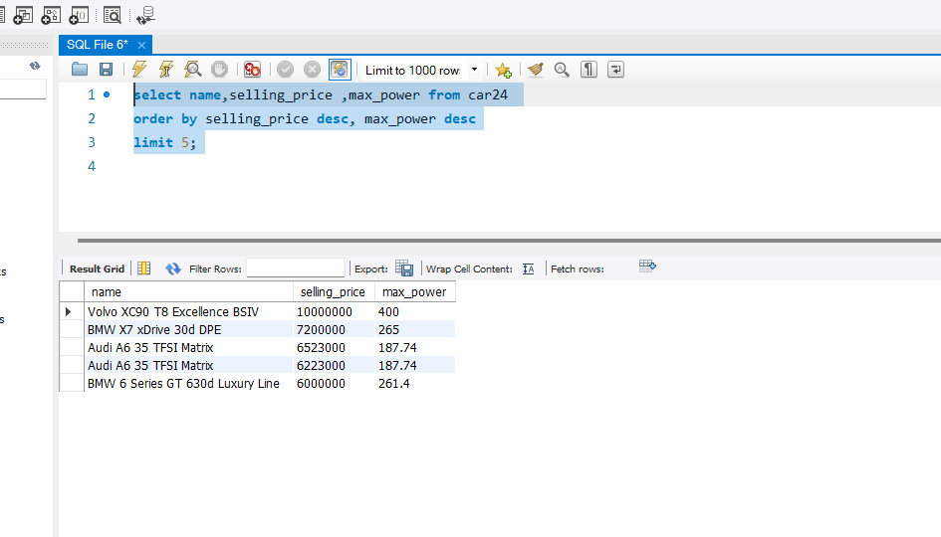

Insight-7

-Count the number of cars which is second owner and have automatic transmission present in dataset

select count(name) from car24

where transmission = "automatic" and owner = "second owner"

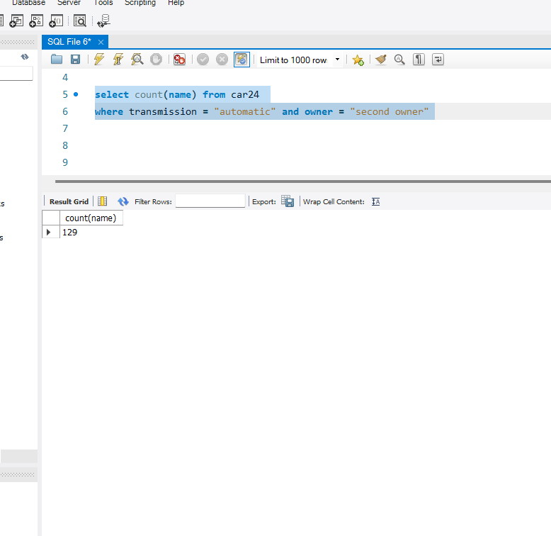

Insight-8

Print the numbers of cars sold in each year order by sold car asc

select year, count(name) as sold_cars from car24

group by year

order by count(name);

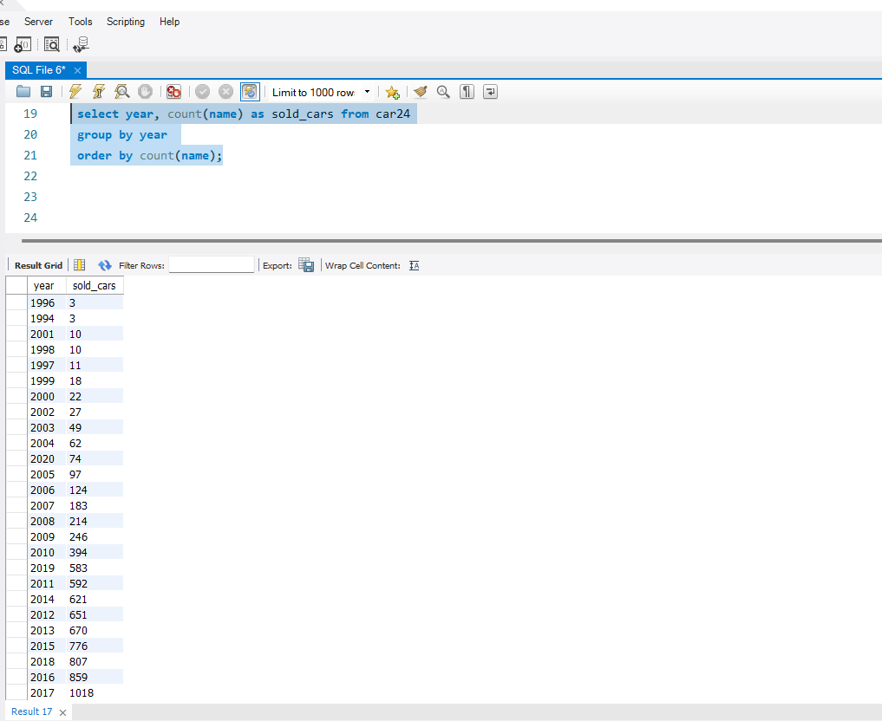

Insight-9

-print the name of top 5 expensive car of bmw company in given datase

select name , selling_price from car24

where name like "bmw%"

order by selling_price asc limit 5

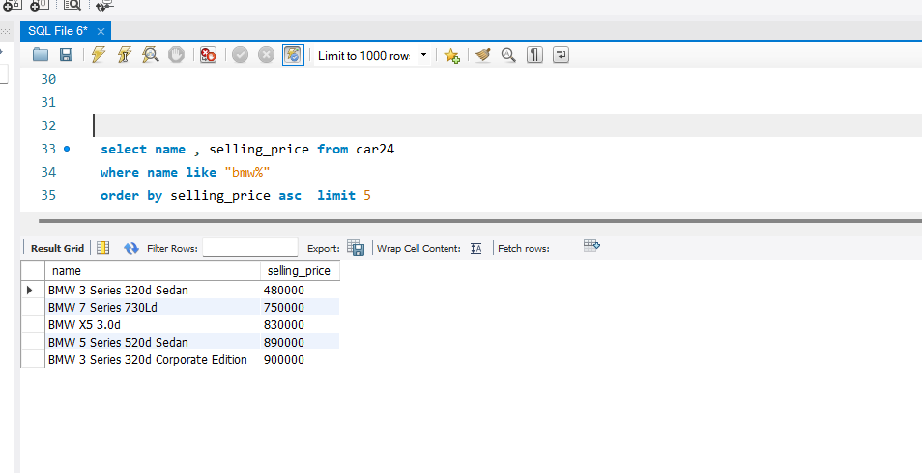

Insight-10

how many first owner cars are there which have more than 5 seats

select count(name) as nums from car24

where seats > 5 and owner = "first owner"

